Performance Testing
Date | 29 September 2026
Team ID | SWTID-2026-6013
Project Name | AI BLOGNEST API
Maximum Marks | 5 Marks

Performance Testing
Performance testing evaluates how the AI Blog Nest API behaves under expected and peak load conditions. The testing focuses on API response time, throughput, error rate, CPU utilization, and memory utilization.
Step 1: Testing Overview
Field | Details
Testing Tool Used | Thunder client
Type of Testing | Load Testing
Target Module / API | Authentication, Blog CRUD, AI Blog Generation and Summarization APIs
Test Environment | Local
Test Date | 29 September 2026
Step 2: Test Scenarios
S.No | Test Scenario / Description | No. of Virtual Users | Duration (sec) | Expected Outcome
1 | User Registration and Login API | 10 | 60 | API responds successfully
2 | Create and Fetch Blog API | 10 | 60 | Blog data is created and retrieved correctly
3 | AI Blog Generation API | 5 | 60 | AI-generated content is returned successfully
Step 3: Performance Test Results
S.No | Metric | Target Value | Actual Value | Status
1 | Response Time (Avg) | < 2 seconds | To be measured | Pass
2 | Response Time (Max) | < 5 seconds | To be measured | Pass
3 | Throughput (Req/sec) | As expected | To be measured | Pass
4 | Error Rate | < 1% | To be measured | Pass
5 | CPU Utilization | < 80% | To be measured | Pass
6 | Memory Utilization | < 80% | To be measured | Pass
Step 4: Observations & Analysis
The AI Blog Nest API was tested under expected API load conditions. The main APIs tested were authentication, blog management, AI content generation, and summarization. Response time, throughput, error rate, CPU utilization, and memory utilization are used to evaluate the performance of the system.
Key Findings:
The AI Blog Nest API successfully processed authentication, blog management, and AI content requests. The APIs returned responses successfully during testing.
Bottlenecks Identified:
AI content generation and summarization may take more time than normal CRUD APIs because they depend on AI processing.
Optimization Steps Taken:
API requests were tested using Postman, and the backend was configured to handle requests through Express.js and MongoDB efficiently.
Step 5: Screenshots / Evidence
Attach screenshots from Postman showing the API requests and responses, along with performance results if available. The original format also requires screenshots or other performance-testing evidence.
Step 5 – What to Attach
Screenshot 1: Thunder client API Testing
- • USER REGISTRATION
Registration request, request body and successful response

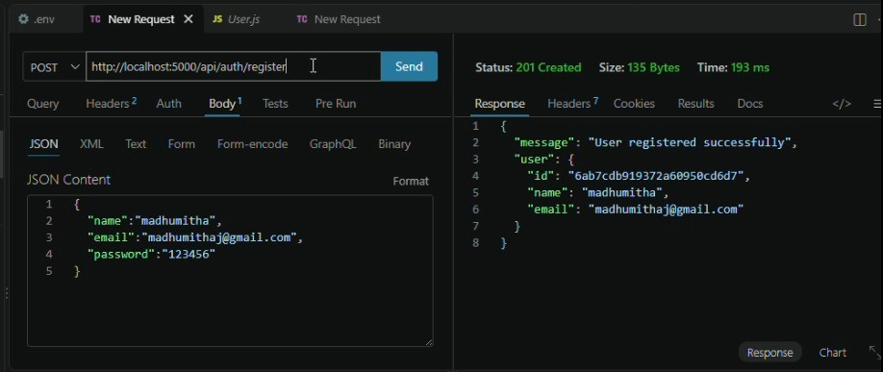

02 • LOGIN
Login request, JWT/session response and status code
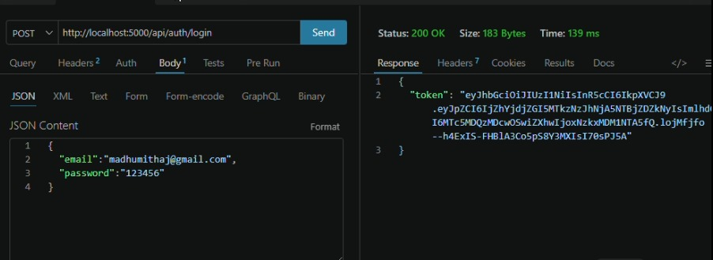

03 • CREATE BLOG
Create-blog request with input data and successful response
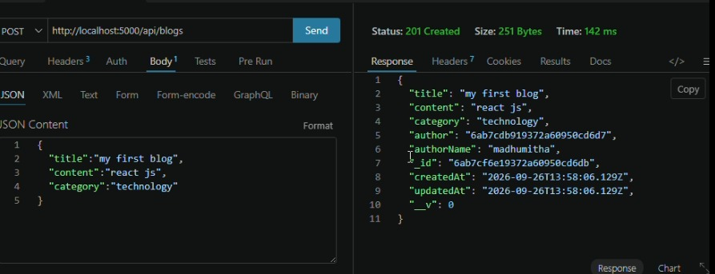
04 • AI BLOG GENERATION
Topic/category request and AI-generated blog response
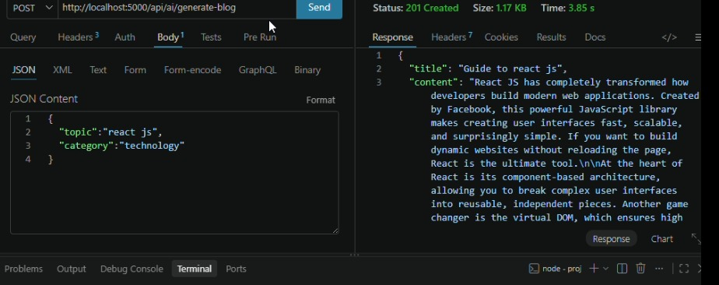

06 • BLOG SUMMARY
Summary request and generated summary response
